Relay used to control the power button solenoid.

GND

+5VDC

Relay Control – DIGITAL pin #6

**Inputs**

5V

5V

5V

**Solenoid Control**

Common - To Solenoid

Normally Open - To +Battery Pack

3 pack from Amazon ($6.99) – Umlife B0899L3CC3

1 Channel Relay Shield Module

DC 5V Indicator Light LED Module for Arduino R3 MEGA 2560 1280 ARM PIC AVR STM32 Raspberry Pi MCU DSP Official Boards Shield

Solenoid used to actuate the power button.

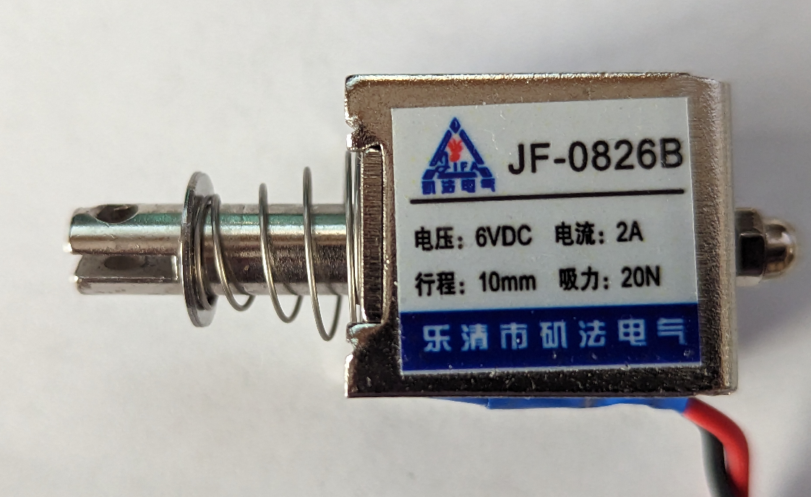

Towards power button

5V

5V

To Relay

-Battery Pack

Amazon ($11.79)

Heyiarbeit DC 6V 20N Push Pull Type Solenoid Electromagnet

2A 12W 10mm Stroke Open Frame Solenoid

Linear Motion

JF-0826B-6V

Line Liquid Crystal Display

Contrast

To DIGITAL pins

+5VDC

GND

5V

5V

5V

5V

5V

5V

5V

5V

5V

5V

5V

5V

Top

Bottom

|  |  |
| --- | --- |
| **LCD Module Pin** | **Uno R3 Pin** |
| D4 | DIGITAL 5 |
| D5 | DIGITAL 4 |
| D6 | DIGITAL 3 |
| D7 | DIGITAL 2 |
| RS | DIGITAL 12 |
| E | DIGITAL 10 |

Photoresistor used to detect white Surface Windows Logo – taped to screen.

Additional circuit connections

**+5VDC**

**Uno IO pin #8**

10K Ohm

**+5VDC**

10K Ohm Pot

**LCD module pin #3 V0**